Gaming-Bets

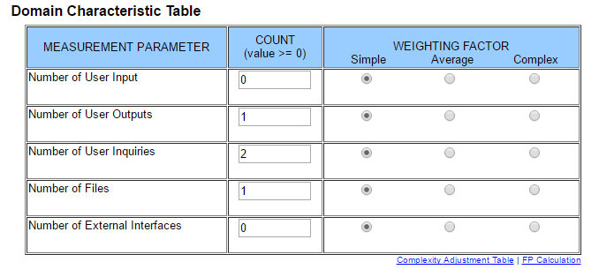

Use-Case Specification: Check Leaderboard

Version 1.0

Revision History

|  |  |  |  |
| --- | --- | --- | --- |
| **Date** | **Version** | **Description** | **Author** |
| 25.10.2015 | 1.0 | Basic Information | Felix Morsbach |

Table of Contents

1. Use-Case Name 4

1.1 Brief Description 4

2. Flow of Events 4

2.1 Basic Flow 4

2.2 Alternative Flows 5

2.2.1 Cannot reach server 5

3 Special Requirements 5

4 Preconditions 5

4.1 App started 5

4.2 Internet Connection 5

5 Postconditions 5

6 Extension Points 5

Use-Case Specification: Check Leaderboard

# Use-Case Name

## Brief Description

This Use-Case will provide the possibility to check the current Leaderboard with all players listed according to their Score.

# Flow of Events

## 2.1 Basic Flow

C:\Users\Felix Morsbach\Documents\GitHub\documents\Use Case\Check Leaderboard\Check Leaderboard.png

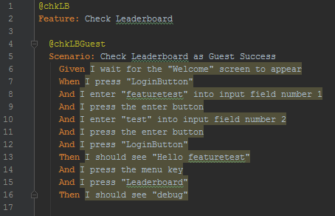

## Alternative Flows

### Cannot reach server

If the application cannot reach the server, the user will be notified if possible via app. He will be asked to try it again later.

# Special Requirements

n/a

# Preconditions

## App started

The app must be running.

## Internet Connection

To submit feedback or a message, an internet connection is necessary.

# Postconditions

n/a

# Extension Points

n/a

# Function Points



This results in a function point calculation of **15.3**.